Gaelic in contemporary Scotland: contradictions, challenges and strategies

Wilson McLeod
University of Edinburgh

Since the mid-1970s, efforts to sustain and revitalise Gaelic in Scotland have gained new momentum and prominence, even as the language has continued to decline in demographic terms. Public and institutional provision for Gaelic, most notably in the fields of education and broadcasting, have grown substantially in recent years, and Gaelic has increasingly been perceived as an essential aspect of Scottish cultural distinctiveness, and as such connected (indirectly rather than directly) to the movement for Scottish self-government. This new recognition of Gaelic has now been enshrined in legislation, the Gaelic Language Act (Scotland) 2005, that grants official status to the language for the first time. The Act also establishes a Gaelic language board, Bòrd na Gàidhlig, with powers to undertake strategic language planning for Gaelic at a national level. The continuing decline in speaker numbers and language use suggests that the policies put in place up to now to sustain and promote Gaelic have been inadequate; better integrated and more forceful strategies are urgently needed if the language shift in favour of English is to be reversed.

Historical and demographic background

Scottish Gaelic (Gàidhlig), a member of the Goidelic branch of the Celtic languages that is closely related to Irish and Manx, is generally believed to have been brought to southwest Scotland by settlers from Ireland in the early centuries of the common era, although a minority view questions the Irish origin and suggests that Gaelic may have reached Scotland many centuries earlier (McLeod 2004a: 15).

Linguists have disagreed as to how and when Scottish Gaelic came to diverge from Irish. The once widely accepted theory of ‘Common Gaelic’ asserted that significant divergence did not begin until c. 1300 (Jackson 1951); more recently, some scholars have challenged this model, arguing that differentiation probably began as soon as Gaelic speakers began to settle in Scotland (Ó Buachalla 2002). Certainly by the early seventeenth century Irish speakers perceived Scottish Gaelic as a distinct, though perhaps still mutually intelligible, variety.

By the eleventh century CE, Gaelic had spread throughout almost all of what is now mainland Scotland and had become established as the language of the Scottish monarchy, but language shift in the south and east of the country during the late Middle Ages, driven by a range of economic and political factors, meant that from the fourteenth century onwards Gaelic became largely confined to the mountainous north and west (the ‘Highlands’ or Gàidhealtachd) (McLeod 2004a: 15-18). Beginning in the late 1300s, commentators from the Scots-speaking Lowlands (or Galldachd) began to develop strongly negative attitudes towards Highlanders, whom they had come to consider backward, violent, even barbarous. These prejudices intensified in the later sixteenth century, when the Reformation transformed Lowland Scotland into a bastion of reformed Protestantism, and new ideologies of kingship and government gave new impetus to the imposition of ‘civility’ on the Gàidhealtachd. Increasingly repressive measures were adopted, notably the Statutes of Iona (1609), which placed strict controls upon the Highland chiefs and forced them to educate their heirs in the Lowlands (Withers 1984: 22-30).

Since the middle of the eighteenth century, a destructive combination of military repression, dramatic economic change, heavy, sometimes forced emigration, persistent material deprivation, and diverse cultural pressures have brought about ongoing language shift from Gaelic to English within the Gàidhealtachd (Withers 1984; MacKinnon 1991). The general trajectory has been one of slow recession towards the northwest, so that the last Gaelic-speaking areas in the Western Isles (the archipelago in the far northwest of Scotland, also known as the Outer Hebrides) are now showing language transmission and use patterns that would have been apparent two hundred years previously in some eastern districts adjoining the Lowlands. However, ‘the decline of Gaelic . . . should not be seen as the simple “retreat” north-westwards of a Gàidhealtachd in which Gaelic was uniformly spoken and common in all domains’; instead the Gàidhealtachd as a whole became ‘less and less strongly Gaelic’, with English becoming more widely known and penetrating into an increasing range of domains (Withers 1998: 326-8).

Map 1 — Parishes in Scotland by the percentages of people
aged 3 and over who spoke Gaelic, 1891

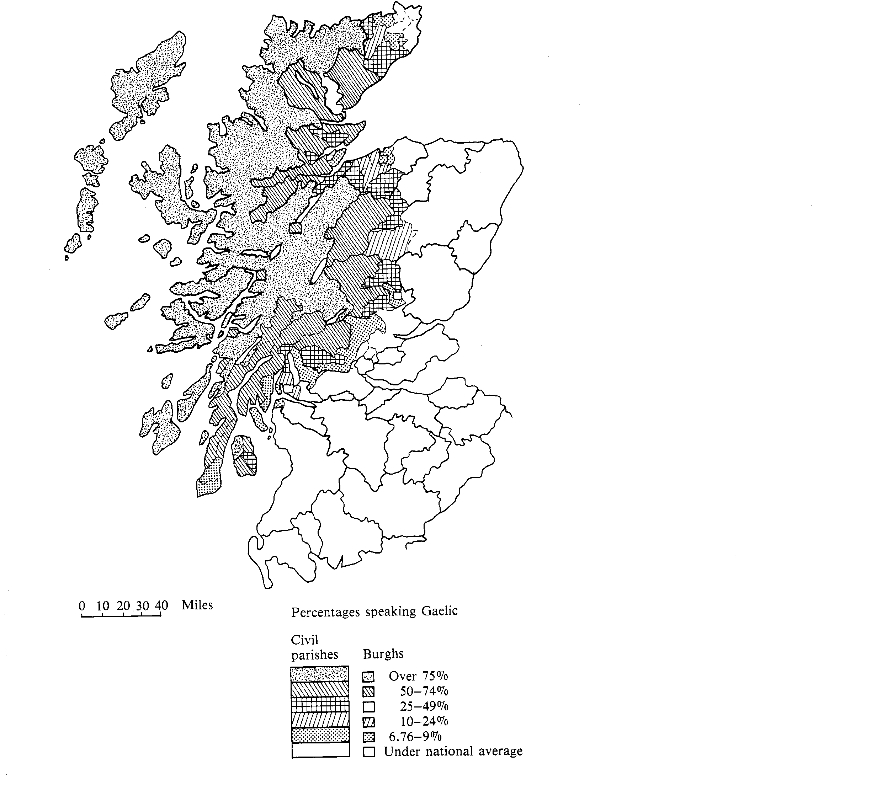
(Source: MacKinnon 1993)

Table 1: Historical demography of Gaelic

Date Total Gaelic speakers Proportion of total
in Scotland Scottish population

1500 150,000? 50?
1755 290,000 22.9
1806 297,823 18.5
1891 254,415 6.3
1951 95,447 1.9
1981 79,397 1.6
1991 65,978 1.3
2001 58,652 1.2

The number of Gaelic speakers fell sharply over the course of the twentieth century, and many formerly Gaelic-speaking areas in the Gàidhealtachd have become entirely English-speaking. The 2001 census showed a total of 58,969 Gaelic speakers aged 3 and over in Scotland, a mere 1.2% of the national population. Some 7,094 persons claimed the ability to read or write Gaelic but not speak it, and a further 27,538 could understand Gaelic but not speak, read or write it (General Register Office for Scotland 2005: Table 1). The rate of decline has now slowed somewhat, however: the drop in speaker numbers between 1991 and 2001 was only about half as great as that between 1981 and 1991, primarily due to an increase among younger age-groups that reflects the impact of Gaelic-medium school education, which grew rapidly in the 1990s, as discussed below ((MacKinnon 2004: 24, 27). This trend notwithstanding, the Gaelic-speaking population is skewed to older age-groups, with some 53% of speakers aged 45 or over (General Register Office for Scotland 2005: Table 4).

The heartland of the language now lies in the Western Isles, where 61% of the 2001 population (15,723 out of 25,745) could speak Gaelic, but with proportions over 80% in some rural districts. Some Inner Hebridean islands, notably in Skye and Tiree, also contain dense concentrations of Gaelic speakers, while the highest level of any mainland parish was recorded in Lochalsh (20.8%). At the same time, some 45% of Gaelic speakers now live in the Lowlands, with significant concentrations in the larger urban areas, particularly greater Glasgow (home to some 11,000 speakers) (MacKinnon 2004: 24; General Register Office for Scotland 2005: Tables 1, 2A and 3). In these Lowland areas, however, the proportion of Gaelic speakers in the population is extremely low, generally 1% or below. The dispersed nature of today’s speech community presents significant challenges for Gaelic development efforts.

Intergenerational transmission of the language is weak; according to the 2001 census, only 69.6% of children aged 3-15 living with two Gaelic-speaking parents could speak Gaelic, as against 36.3% of those living with a lone Gaelic-speaking parent and a mere 22.1% of those living with two parents, only one of whom spoke Gaelic (with this last being the most common arrangement, some 61% of the families in which at least one parent could speak Gaelic) (General Register Office for Scotland 2005: Table 15). The 2001 census showed that only 26.8% of the 3-4 age group in the Western Isles could speak Gaelic, which gives a rough indicator of the level of home (rather than school) based language acquisition (General Register Office for Scotland 2005: Table 5). Gaelic thus appears to be seriously endangered in the very last districts where it remains a majority language.

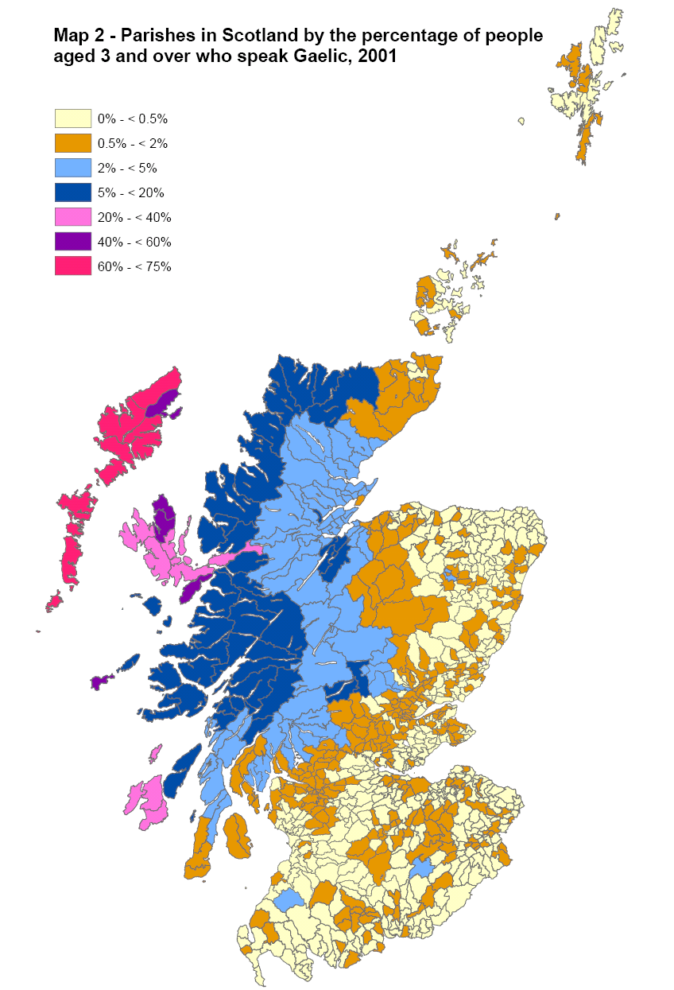

(Source: General Register Office for Scotland 2005)

All Gaelic speakers today are effectively bilingual in English, with monoglot speakers having disappeared from the scene in the last quarter of the twentieth century. During the last few decades almost all Gaelic-speaking children have acquired English in infancy rather than in school (Lamb 2001: 10-11; Gillies 1993: 222). Although many older speakers are Gaelic-dominant (although not with regard to matters with which they became familiar through formal, English-medium education), most younger speakers are strongly English-dominant in all domains (Lamb 2001: 10-13). Learners of Gaelic are relatively rare, probably comprising 5-10% of the speaker population; this low level reflects the traditional exclusion of Gaelic from the Scottish education system, but proportions are now increasing due to the recent expansion of Gaelic-medium education, as discussed below.
Literacy levels are also fairly low: according to the 2001 census, only 67% of Gaelic speakers could read Gaelic and only 54% could write it (General Register Office for Scotland 2005: Table 2A), although literacy levels among learners of the language tend to be significantly higher. At the same time, many of those who can read and/or write Gaelic do not necessarily do so frequently or comfortably (Lamb 2001: 17), a pattern that poses considerable challenges for language development strategy.

Unlike its Irish counterpart, the Scottish census asks no questions about language use, but it is clearly the case that Gaelic is in severe decline as a community language and that some Gaelic speakers make relatively limited use of the language. Research in the Western Isles heartland suggests a significant and ongoing decrease in the level of community Gaelic use since the 1970s (MacKinnon 2006; NicAoidh 2006). Disturbingly, Western Isles residents who participated in a major recent survey indicated that they tend to use English even in circumstances or settings when they are aware it is possible for them to use Gaelic (NicAoidh 2006: 79, 85; Western Isles Language Plan Project 2005: 23-4). As for the urban Lowlands, a recent survey of Gaelic speakers in Edinburgh found that only 34% used Gaelic at least once every day and only 3% used more Gaelic than English every day (McLeod 2005: 12).

In summary, every sociolinguistic indicator suggests that Gaelic is now in a severely weakened state and that its decline is ongoing, despite the revitalisation initiatives of recent years. Policies and programmes to strengthen the position of Gaelic therefore function within a very challenging sociolinguistic context.

Gaelic as an ambiguous national language

As outlined above, Gaelic has been a minority language in Scotland for several centuries, and it has not been widely spoken in the economically and politically dominant regions of the country for even longer. Its position thus differs considerably from its sister Celtic languages Welsh and Irish, for example, which were until relatively recently the languages of the majority of the population, spoken in almost all parts of the national territory, and which retain an unchallenged symbolic authority as national languages despite their minority status. The significance of Gaelic in Scottish national life and Scottish national identity, in contrast, is somewhat tenuous, and its proper role is much contested; for some Scots, Gaelic is of merely regional rather than genuinely national importance, and a small but vocal sector of Scottish opinion is persistently hostile to the language (McLeod 2001b).

At the same time, the so-called ‘Gaelic renaissance’ of recent decades is clearly connected to strengthening perceptions of Gaelic as a national language, something of importance to Scotland as a whole; it is also related to the increasing emphasis on Scottish political and cultural distinctiveness in general, a shift made most manifest in the devolution settlement of 1998, which led to the establishment of the Scottish Parliament in 1999. Reflecting these shifting outlooks, a survey carried out in 2003 showed that 66% of the Scottish population agreed with the proposition that ‘Gaelic is an important part of Scottish life and needs to be promoted’, a much more positive result than emerged from similar research conducted in the early 1980s (Market Research UK 2003; MacKinnon 1981). Public support for Gaelic tends to be shallow and vague, however, and does not necessarily translate into backing for proactive language revitalisation measures (McLeod 2001b).

At the same time, the link between the Gaelic language and Scottish nationalism — in the conventional sense of the term in Scottish parlance, i.e. support for the establishment of a Scottish state independent of the existing United Kingdom — is a weak one. Support for Scottish independence by no means signals a commitment to Gaelic, and speaking Gaelic by no means signals support for Scottish independence. Gaelic revitalisation efforts in Scotland thus have little connection, overt or otherwise, to the nationalist cause, and are not associated with any one political party or shade of political opinion.

A common metaphor used with regard to Gaelic is that of ‘raising the profile’ of the language — the idea that the language has become more prominent and more visible in Scottish life. This heightened profile can be seen in myriad places and ways, from increased bilingual signage to award-winning television programmes to intensified consideration of Gaelic issues by the new Scottish Parliament. The danger comes in assuming a direct connection between this increasing visibility of Gaelic and its actual functioning as a living language in families and communities.

Official and institutional status

The most significant formal statement of Gaelic’s status as a national language is given in the preamble to the recently enacted Gaelic Language (Scotland) Act 2005, which declares Gaelic to be ‘an official language of Scotland commanding equal respect with the English language’. This legislation, which followed a decade-long campaign by Gaelic organisations, is a historic step forward for the language, even though it is weak in comparison to language legislation in jurisdictions such as Catalunya and Canada, or even Wales, whose Welsh Language Act 1993 provided a model for the Gaelic Act (see Dunbar 2006: 13-20). This statutory recognition follows the United Kingdom’s 2001 ratification of the European Charter for Regional or Minority Languages and designation of Gaelic under Part III thereof (Dunbar 2003a; Dunbar 2006: 14-15).

Among the Act’s key provisions are the following:

- The official language agency, Bòrd na Gàidhlig, initially established in 2003, is now placed on a statutory footing and given a range of specified powers and responsibilities, including the preparation of a National Gaelic Language Plan and guidance to education authorities with regard to Gaelic-medium education.
- The Bòrd may require any public body (including local administrative authorities) in Scotland to prepare a Gaelic language plan, although it is contemplated that the terms of such plans will vary considerably according to the extent to which those whom the body serves use Gaelic and the potential for developing the use of Gaelic in connection with the body’s work. This ‘sliding scale’ approach reflects the view of Gaelic organisations that different levels of provision are appropriate in different parts of Scotland, but that Scotland-wide coverage is essential given Gaelic’s increasingly national rather than regional profile and the increasing dispersal of the Gaelic-speaking population.

In many respects, however, the omissions from the Act may be more significant than its actual provisions:

- The phrase ‘equal respect’ as used in the preamble (quoted above) has no clearly recognised meaning in law and was chosen precisely to avoid any suggestion that Gaelic would have equal validity or parity of esteem with English, or that the Act might be construed as imposing a general duty to institutionalise Gaelic-English bilingualism. (In this respect the Act differs fundamentally from the Welsh Language Act 1993, which requires that Welsh and English are to be treated ‘on a basis of equality’).
- The National Gaelic Language Plan will not be legally enforceable, and there is a danger it will end up gathering dust on a shelf unless it is imbued with sufficient authority.
- The Act makes no requirements about the content of public bodies’ language plans, and it is possible that some bodies may contemplate merely tokenistic schemes that do not involve the delivery of any Gaelic-medium services.
- Bòrd na Gàidhlig’s powers to enforce compliance with Gaelic language plans are weak in comparison to those of comparable agencies or offices in other countries.
- There is nothing in the Act establishing rights to receive, or obligations to deliver, Gaelic education or to use Gaelic in the courts; indeed, the Act creates no language rights at all.
- Because it was enacted by the Scottish Parliament in Edinburgh rather than the Westminster Parliament in London, the Act covers Scottish public bodies only and does not extend to UK-wide bodies. As such, important authorities ranging from the Inland Revenue and the Department for Work and Pensions to the Post Office and Coast Guard will have no obligations under the Act. This makes it difficult to develop an integrated strategy for Gaelic development in the public sector, and may lead to confusion and frustration for Gaelic speakers.
- The Act does not address the private sector at all; indeed, the possibility of imposing Gaelic-related obligations on private companies was never seriously contemplated.

The Act clearly provides great opportunities for Gaelic development, particularly as there has been little provision for Gaelic in the public sector up to now. For example, the devolved Scottish government, the Scottish Executive, produces only a small number of publications in Gaelic each year and these are largely confined to topics specifically relating to Gaelic or the Gaelic-speaking island communities. Similarly, although the Scottish Parliament is fitted with bilingual English-Gaelic signs and accommodates the use of Gaelic in its debates and committee work, the proportion of business conducted through Gaelic is miniscule. Certain local administrative authorities and other public bodies have developed Gaelic policies, but these tend to be limited in scope. Thus the local authority for the Western Isles, Comhairle nan Eilean Siar, has established a bilingual policy for its operations, but it has no real strategic plan to institutionalise bilingualism or make Gaelic-medium services systematically available to the public. Gaelic was identified as being ‘essential’ or ‘desirable’ for fewer than 5% of the vacant posts the authority advertised in 2000-1 (McLeod 2001a: 19).

The growth of Gaelic education

Gaelic was initially excluded entirely from the state school system established in 1872 and it remained at the margins until the 1970s. Although there had been limited initiatives from the early 1960s onwards, Gaelic-medium education in Scotland began only in 1985, building on the successes of Gaelic-medium pre-schools organised by Comhairle nan Sgoiltean Àraich (the Gaelic Pre-school Council). In the 2005-6 school year there were some 2,068 primary school pupils in 61 Gaelic schools (or units within schools) across Scotland. Although all of these are state schools, there being no Gaelic provision in denominational or private schools, their geographical and sociolinguistic settings are very diverse: some are located in communities in which Gaelic remains widely used, some in areas of the Gàidhealtachd where language shift has occurred relatively recently, and some in Lowland towns and cities. The language profiles of pupils are equally varied: while a proportion, especially in Gaelic-speaking island areas, are first-language Gaelic speakers, in many schools a large majority of the children enrolled come from non-Gaelic-speaking homes and are acquiring Gaelic through immersion. In line with international experience, research suggests that children in Gaelic-medium education keep pace with, and in some respects outperform, children in English-medium education (Johnstone et al. 1999).

Given the traditional exclusion of Gaelic from the Scottish educational system, the establishment and expansion of Gaelic-medium education has been a development of great significance for the language (see MacLeod 2003; Robertson, 2001). Even so, the scale of provision remains very small; well under 1% of Scotland’s primary school children receive Gaelic-medium education, and very few of the rest acquire any knowledge of the language at all. Only 14 of 32 education authorities currently offer Gaelic-medium education at any of their schools, and there is no legal obligation to make it available. It has been calculated that the numbers enrolled in Gaelic-medium education would need to grow five-fold simply to maintain the existing Gaelic-speaking population, and even in the Western Isles, less than one-quarter of children receive their primary education through the medium of Gaelic, as English-medium education remains the default option (MacKinnon 2006: 66).

Another worrisome trend is the slowing of growth in the Gaelic educational sector in recent years. Only six new Gaelic primary units have opened since 1997, while the numbers of pupils in Gaelic-medium primary education have gone up by only 2.2% annually between 1998-9 and 2005-6, compared to 31% each year between 1988-9 and 1997-8. One major reason for this slowdown has been the shortage of trained teachers, a common problem in minority-language education. Some improvements in training structures have been put in place in recent years, but there has been no large-scale commitment of resources of the kind seen, for example, in the Basque Country (McLeod 2003).

One unusual feature of Gaelic-medium primary education in Scotland has been its reliance on Gaelic-medium units within English-medium schools rather than free-standing Gaelic schools of the kind preferred in Ireland, Wales and other minority language jurisdictions (McLeod 2003). Because children in Gaelic ‘units’ are surrounded by English-monoglot fellow pupils and staff, language immersion is significantly constrained and Gaelic language acquisition is not as effective as it might be (see MacNeil & Stradling 2000; cf. Johnstone et al. 1999). At present there is only one all-Gaelic school in Scotland, in the city of Glasgow (although another is now under construction in the city of Inverness); recent proposals to develop all-Gaelic schools in rural districts in the Gàidhealtachd have encountered significant political opposition (much of it from local residents, including Gaelic speakers, concerned about the impact on local children receiving monoglot English education).

As with most other minority languages, Gaelic-medium education is much less developed at secondary level than primary. A 1994 government report described the expansion of Gaelic-medium provision at secondary level as ‘neither desirable nor feasible in the foreseeable future’ (Scottish Office Education Department 1994: 3), a view that has only gradually been superseded. Only 315 secondary students received even part of their education through Gaelic in 2005-6 (a decline from 375 in 2002-3) and only 20 secondary schools, almost all of them within the traditional Gàidhealtachd area, offered any Gaelic-medium education. Gaelic-medium provision, moreover, is overwhelmingly concentrated at the lower secondary levels; 76% of these pupils were in the first two years of secondary school. Provision for Gaelic as a subject is somewhat better: 981 pupils at 36 secondary schools were enrolled in classes for fluent speakers in 2005-6, and 2,718 in classes for learners of the language at 36 schools. Even so, only 42 secondary schools out of 386 in Scotland currently offer Gaelic in any form.

As at primary level, Gaelic-medium secondary education has hitherto been confined to units, but the first all-Gaelic secondary school will open in Glasgow in summer 2006. This new school will eventually offer an entirely Gaelic-medium secondary curriculum.
Perhap surprisingly, provision for Gaelic in further and higher education is better developed in some respects than in the school system. The Gaelic college on the Isle of Skye, Sabhal Mòr Ostaig, now offers four degree courses taught entirely through the medium of Gaelic; two of these are also available at Lews Castle College in Stornoway, Isle of Lewis. Gaelic is also used as a teaching medium for some courses at the Celtic studies departments at the universities of Aberdeen, Edinburgh and Glasgow (see Robertson 2001: 19-21).

Up to now, there has been little national coordination in Gaelic education policy, partly because the Scottish education system is decentralised in certain key respects. Guidance developed by Bòrd na Gàidhlig under the Gaelic Language Act should help develop a real system of Gaelic education for the first time, even if the Act does not formally require the inclusion of Gaelic in the curriculum or entitle children to study the language.

The Gaelic movement in Scotland has arguably placed excessive emphasis on Gaelic education within its revitalisation strategies. Leading sociolinguist Joshua Fishman has criticized the Gaelic movement as relying almost exclusively on ‘higher-order props’ (Fishman 1991: 380). Fishman makes clear that minority-language education must be connected to broader community-based language initiatives and intergenerational mother-tongue transmission in the home, and in their absence will lead to expensive and disappointing failure ((Fishman 1991: 380). Thus, even if the numbers of children enrolled in Gaelic-medium education (including secondary and tertiary education), were to increase dramatically – ten-fold or more – international experience makes clear that much more would still need to be done in order to ensure active, lifelong use of the language and transmission to future generations (McLeod 2003). At present there is relatively little awareness of these difficulties in Scotland; reliance on formal education as the principal means of linguistic regeneration is generally accepted without question or analysis.

The expansion of Gaelic broadcasting

Although Gaelic broadcasting in Scotland began as early as 1923, it remained minimal in scale until the 1970s (Lamb 1999). There have since been important advances with regard to radio and, especially, television, but there is not yet a full service in either medium.

From 1985 onwards, the BBC Gaelic radio service, Radio nan Gaidheal, has steadily increased the amount of hours broadcast and broadened its geographical range. Programming now exceeds 65 hours per week and is accessible not only to the great majority of Scotland’s Gaelic-speaking population but also to the great majority of the Scottish population as a whole (although the service is still unavailable in some parts of the country). Radio nan Gaidheal is also available worldwide via the Internet. Radio nan Gaidheal has a very high level of audience penetration within the Gaelic community and (much more so than television) plays a key role in relation to the publicising and discussion of Gaelic affairs (Dunbar 2003b, 2006). Above and beyond the BBC service, several private radio stations in Scotland offer a few hours a week of Gaelic programming, and a Gaelic ‘podcast’ service based in the United States has recently been established.

Gaelic television expanded rapidly as a result of the Broadcasting Act 1990, which established a Gaelic Television Fund (now known as the Gaelic Broadcasting Fund) currently worth £8.5 million (13 million euro) annually. Some 350 hours of programming (including repeats) are broadcast each year, some of it on the public BBC channels, some on private channels owned by the Scottish Media Group. Gaelic television has reached a crossroads, however: annual budgets have not been increased to reflect inflation (so that the value of the Gaelic Broadcasting Fund is now some 30% less than in the early 1990s) and Gaelic programmes on the private channels have increasingly been shunted to inconvenient time slots late at night. Although a government-appointed commission formally recommended in 2000 that a separate, dedicated Gaelic television channel should be established, and the government committed itself to this goal by acceding to paragraph 11 1 a 2 of the European Charter for Regional or Minority Languages, progress stalled for several years in the early 2000s, for a combination of political and financial reasons (Dunbar 2006: 7-10). It now appears that a new digital channel, delivered by the BBC and perhaps broadcast only via satellite in the first instance, will be launched sometime in 2007. According to current plans, however, this new channel would only broadcast 1.5 hours of new material per day, along with several hours of repeats.
Broadcasting already consumes the lion’s share of total public expenditure on Gaelic development, and this proportion is set to increase when the digital television channel is established. As in other minority-language jurisdictions, debates continue about the proper role of the Gaelic media in language revitalisation strategy. Proponents argue that investment in broadcast media, especially television, is necessary to promote a contemporary image for the language and to meet the needs of contemporary Gaelic speakers’ lifestyles, but it is by no means clear that increased investment in Gaelic television will or can deliver concrete benefits in terms of Gaelic language acquisition and use (see Dunbar 2003b; Cormack 2006).

Gaelic in print

The use of Gaelic in print media and in publishing is rather less impressive than the position in broadcasting, a consequence of both less generous funding and low Gaelic literacy levels. The only all-Gaelic newspaper, An Gàidheal Ùr, comes out on a monthly basis, principally as a free supplement to local papers in the Gàidhealtachd, and its financial situation is consistently precarious. There has never been a daily Gaelic newspaper, and weeklies have been very sporadic. Gaelic articles appear twice a week in the nationally distributed Scotsman newspaper and once a week in the Highland edition of the Aberdeen Press and Journal and approximately half a dozen local papers. Gaelic periodicals are very scarce: the long-running Gaelic quarterly Gairm published its last issue in autumn 2002, and its replacement Gath has appeared less regularly.

Book publishing is on a very small scale, a few dozen titles a year, with almost no adult non-fiction being produced. Considerable emphasis has been placed on books for children and teenagers in recent years, and the success of the Ur-Sgeul initiative, which has produced an impressive series of novels and short stories for adults from 2003 onwards, has demonstrated how concentrated investment in Gaelic publishing can bring significant payoffs. Academic writing in Gaelic, principally on linguistic, literary and historical topics, has also become rather more common in recent years, in line with the growth in Gaelic-medium higher education.

As with other minority languages, the Gaelic presence on the Internet has expanded rapidly. Above and beyond materials produced by Gaelic organisations and public bodies in Scotland, a number of Gaelic discussion groups have been established, together with scores of personal web pages and ‘blogs’ in Gaelic (many of them from outside Scotland) and Gaelic-language sections on web-based encyclopedias. When the growth of e-mail is also taken into account, Gaelic may well be more widely written than ever before.

Issues in corpus planning

A striking feature of the Gaelic situation has been the relative neglect of corpus planning within revitalisation efforts. In contrast to many other minority language movements, there has never been any kind of linguistic academy, institute or unit with responsibility for the linguistic codification or elaboration of Gaelic, and initiatives in the fields of orthographic and grammatical standardisation, terminological development and lexicography have been limited in their range and characterised by occasional bursts of activity rather than integrated, cumulative endeavour. There is now a significant disjuncture between new status planning initiatives — the use of Gaelic in secondary and higher education and official business, for example — and the low level of corpus development, so that the language is sometimes not fully functional for these high-level purposes (see McLeod 2004b). Work is needed in a number of areas, perhaps most immediately in relation to terminological development and translator training, if Gaelic is to be successfully institutionalised in the wake of the Gaelic Language Act. Full-scale, fully functional dictionaries and guidebooks concerning grammar and stylistics are also urgently required. Such initiatives are likely to succeed only if a specialist coordinating body is established, perhaps under the auspices of Bòrd na Gàidhlig, perhaps under the universities’ Board of Celtic Studies.

Conclusion

The position of Gaelic in Scotland has become increasingly contradictory. Public support for the language, in terms of government financing, institutional provision and favourable attitudes among the general Scottish population, has never been greater, but the language has continued to weaken in terms of speaker numbers and intensity of use, to the point where it now can hardly be said to function as a community language anywhere in Scotland. Rates of intergenerational transmission remain low, and any influx of new speakers via Gaelic-medium school education or adult learning can only be a very poor substitute. The main question now is whether the new policy paradigm that has been put in place with the enactment of the Gaelic Language Act and the creation of Bòrd na Gàidhlig will bring about real progress in confronting these challenges. There is a danger that language planning strategies may place excessive emphasis on formal policies and institutional provision by public authorities and fail to tackle the central problems of language acquisition and use in families and communities.

References

Cormack, Mike (2006). ‘The media, language maintenance and Gaelic’, in McLeod (2006), 211-19.

Council of Europe (2003). Application of the Charter in the United Kingdom.
Strasbourg: Council of Europe.

Dunbar, Robert (2003a). The Ratification by the United Kingdom of the European Charter for Regional or Minority Languages. Mercator-Legislation Working Paper 10. Barcelona: Mercator/CIEMEN.
Dunbar, Robert (2003b). ‘Gaelic-medium Broadcasting: Reflections on the Legal Framework from a Sociolinguistic Perspective’, in Towards Our Goals in Broadcasting, the Press, the Performing Arts and the Economy: Minority Languages in Northern Ireland, the Republic of Ireland, and Scotland, ed. by John M. Kirk and Dónall P. Ó Baoill, 73-82. Belfast: Cló Ollscoil na Banríona.
Dunbar, Robert (2006). ‘Gaelic in Scotland: the legal and institutional framework’, in McLeod (ed.) (2006), 1-23.

General Register Office for Scotland (2005). Cunntas-Sluaigh na h-Alba 2001: Aithisg Ghàidhlig / Scotland’s Census 2001: Gaelic Report. Edinburgh: General Register Office for Scotland (http://www.gro-scotland.gov.uk/statistics/census/ censushm/scotcen/scotcen2/scotcen-gaelic/).

Gillies, William (1993). ‘Scottish Gaelic’, in The Celtic Languages, ed. by Martin J. Ball with James Fife, 145-227. London: Routledge.

Jackson, Kenneth (1951). ‘Common Gaelic: The Evolution of the Goidelic Languages’. Proceedings of the British Academy, 37 , 71-97.

Johnstone, Richard, et al. (1999). The Attainments of Pupils Receiving Gaelic-medium Primary Education in Scotland. Stirling: Scottish Centre for Information on Language Teaching and Research..

Kennedy, Mike (2002). Gaelic Nova Scotia: An Economic, Cultural, and Social Impact Study. Halifax: Nova Scotia Museum.

Lamb, William (1999). ‘A Diachronic Account of Gaelic News-speak: The Development and Expansion of a Register’. Scottish Gaelic Studies, 19, 141-71.
Lamb, William (2001). Scottish Gaelic. Languages of the World/Materials 401. Munich: Lincom Europa.

MacDonald, Sharon (1999). ‘The Gaelic Renaissance and Scotland’s Identities’. Scottish Affairs, 29, 100-18.

MacKinnon, Kenneth (1981). Scottish Opinion on Gaelic: A report on a national attitude survey for An Comunn Gàidhealach undertaken in 1981. Hatfield: Hatfield Polytechnic.
MacKinnon, Kenneth (1991). Gaelic: A Past and Future Prospect. Edinburgh: Saltire Society.
MacKinnon, Kenneth (1993). ‘Scottish Gaelic Today: Social History and Contemporary Status’, in The Celtic Languages, ed. by Martin Ball, 491-535. London: Routledge.
MacKinnon, Kenneth (2004). ‘Gaelic in the 2001 census: a few green shoots amidst the gloom’, in Doonsin’ Emerauds: New Scrieves anent Scots an Gaelic / New Studies in Scots and Gaelic, ed. by J. Derrick McClure, 24-35. Belfast: Cló Ollscoil na Banríona.
MacKinnon, Kenneth (2006). ‘The Western Isles Language Plan: Gaelic to English language shift 1972–2001’, in McLeod (ed.) (2006), 49-71.

MacLeod, D. J. (2003). ‘An Historical Overview’, in Nicolson & MacIver (2003), 1-14.

McLeod, Wilson (2001a). The State of the Gaelic Economy: A Research Report. Edinburgh: Celtic and Scottish Studies, University of Edinburgh (www.arts.ed.ac.uk/celtic/poileasaidh/gaeljobsrep3.pdf).
McLeod, Wilson (2001b). ‘Gaelic in the New Scotland: Politics, Rhetoric and Public
Discourse’. Journal on Ethnopolitics and Minority Issues in Europe (www.ecmi.de/jemie/download/JEMIE02MacLeod28-11-01.pdf)
McLeod, Wilson (2003). ‘Gaelic Medium Education in the International Context’, in Nicolson & MacIver (2003), 15-34.
McLeod, Wilson (2004a). Divided Gaels: Gaelic Cultural Identities in Scotland and Ireland c.1200-c.1650. Oxford: Oxford University Press.

McLeod, Wilson (2004b). ‘The challenge of corpus planning in Gaelic development’. Scottish Language, 23, 68-92.
McLeod, Wilson (2005). Gàidhlig ann an Dùn Èideann: Cleachdadh agus Beachdan / Gaelic in Edinburgh: Usage and Attitudes. Edinburgh: Celtic and Scottish Studies, University of Edinburgh (www.arts.ed.ac.uk/celtic/poileasaidh/ aithisggaidhligdeURB.pdf)
McLeod, Wilson (ed.) (2006). Revitalising Gaelic in Scotland: Policy, Planning and Public Discourse. Edinburgh: Dunedin Academic Press.

MacNeil, Morag M., and Stradling, Bob (2000). Home and Community: Their role in enhancing the Gaelic language competencies of children in Gaelic-medium education. Sleat, Isle of Skye: Lèirsinn Research Centre.

Market Research UK (2003). Attitudes to the Gaelic Language. Glasgow: Market Research UK.

Millar, Robert McColl (2005). Language, Nation and Power: An Introduction. Basingstoke: Palgrave Macmillan.

NicAoidh, Magaidh (2006). ‘Pròiseact Plana Cànain nan Eilean Siar: A’ chiad ìre — rannsachadh air suidheachadh na Gàidhlig anns na h-Eileanan Siar’ [The Western Isles Language Plan Project: Stage 1 — research on the situation of Gaelic in the Western Isles], in McLeod (ed.) (2006), 73-86.

Nicolson, Margaret, and MacIver, Matthew (eds) (2003). Gaelic Medium Education. Edinburgh: Dunedin Academic Press.

Ó Buachalla, Breandán (2002). ‘Common Gaelic Revisited’, in Rannsachadh na Gàidhlig 2000, ed. by Colm Ó Baoill and Nancy R. McGuire, 1-12. Aberdeen: An Clò Gaidhealach.

Oliver, James (2005). ‘Gaelic and Identities in Scotland: Contexts and Contingencies’. Scottish Affairs , 51, 1-24.

Robertson, Boyd (2001). The Gaelic language in education in the UK. Leeuwarden: Mercator-Education (www1.fa.knaw.nl/mercator/regionale_dossiers/regional_dossier_gaelic_in_uk.htm)

Scottish Office Education Department (1994). Provision for Gaelic Education in
Scotland: A Report by HM Inspectorate of Schools. Edinburgh: Her Majesty’s Stationery Office.

Western Isles Language Plan Project / Pròiseact Plana Cànain nan Eilean Siar (2005). Research and Outcomes of Phase 1 of the Project: Final Report / Rannsachadh agus Toraidhean Ìre 1 den Phròiseact: Aithisg Dheireannach. Stornoway: Western Isles Language Plan Project / Pròiseact Plana Cànain nan Eilean Siar (http://www.planacanain.org.uk/planaire1.pdf).

Withers, Charles W. J. (1984). Gaelic in Scotland 1968-1981: The Geographical History of a Language. Edinburgh: John Donald.
Withers, Charles W. J. (1998). ‘A Social History and Geography of Gaelic in Scotland 1806-1901’, in Language and Community in the Nineteenth Century, ed. by Geraint H. Jenkins, 317-40. Cardiff: University of Wales Press.

Scots is a Germanic speech form closely related to English, generally described (in Scotland at least) as a distinct language. Following the decline of Gaelic in Lowland Scotland from the twelfth century onwards, Scots became the language of administration and commerce before gradually losing its prestige from the sixteenth century due to Anglicising forces (see Millar 2005). Although arguably much more widely spoken than Gaelic today, provision for Scots is minimal, and efforts on its behalf tend to focus overwhelmingly on corpus planning and literary matters.
There are no reliable data for the numbers of Gaelic speakers outside Scotland. In particular, questions concerning Gaelic language ability are not included in the census form used in other parts of the United Kingdom. There are now only a few hundred Gaelic speakers remaining in Nova Scotia, although there were some 50,000 speakers in there at the turn of the twentieth century, following heavy emigration from from the Gàidhealtachd in the late eighteenth and early nineteenth centuries (see Kennedy 2002).
Conversely, 32% of the Gaelic speakers aged 3-15 came from families in which neither parent could speak Gaelic (General Register Office for Scotland 2005: Table 15), reflecting the decision of non-Gaelic-speaking parents to send their children to Gaelic-medium education.
There is no comprehensive and satisfactory analysis of Gaelic and Scottish identity; for introductory discussions, see Macdonald 1999; McLeod 2001b; and Oliver 2005.
With regard to the term ‘state’ here, note that the Scottish educational system is and always has been entirely separate from that of England. This is a key feature of the 1707 Union between Scotland and England.
All enrolment figures based on data compiled by the Faculty of Education, University of Strathclyde.
The UK government has, however, bound itself to paragraph 8 a 1 of the European Charter for Regional or Minority Languages, which requires it ‘to make available primary education in’ Gaelic. In its 2003 report on the implementation of the Charter in the UK, the Council of Europe’s Committee of Experts described this commitment with regard to education as ‘the most ambitious available’ and determined that provision was in fact ‘patchy, which in practice makes it difficult and sometimes impossible for children to obtain this education’ (Council of Europe 2003: 32 para. 191, 33 para. 207). In light of this patchiness, the Committee of Experts ruled that this commitment was only party fulfilled; the Council’s Committee of Ministers then gave as its first recommendation to the UK government following the Experts’ investigation that it should ‘make primary and secondary education in Scottish Gaelic generally available in the areas where the language is used’ (Council of Europe 2003: 70 para. 1).
30 secondary schools offer Gaelic classes both for fluent speakers and for learners, 6 offer classes for fluent speakers only and another 6 offer classes for learners only.
Paragraph 11 1 a 2 provides that ‘to the extent that radio and television carry out a public service mission’ the government must ‘encourage and/or facilitate the creation of at least one radio station and one television channel in’ Gaelic. In its 2003 report on the implementation of the Charter in the UK, the Council of Europe’s Committee of Experts ruled that this commitment was ‘not fulfilled in respect of television’ (Council of Europe 2003: 40, para. 265). The Committee of Ministers then formally recommended that the UK government should ‘facilitate the establishment of a television channel or an equivalent television service in Scottish Gaelic and overcome the shortcomings in Scottish Gaelic radio broadcasting’ (Council of Europe 2003: 70, para. 4).

